**2016**

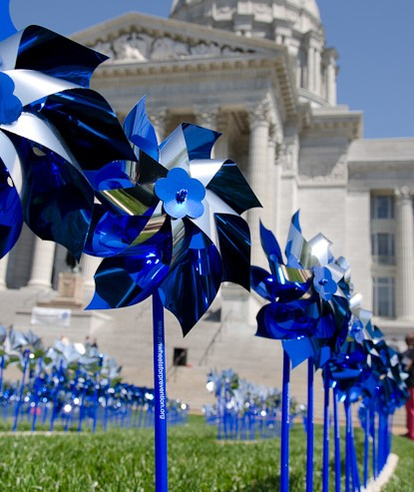

**Pinwheels for Prevention™ Campaign Toolkit**

Macintosh HD:Users:Missouri KidsFirst:Downloads:Missouri (2) 2:PfP Logo_MO_2C.eps



Missouri KidsFirst is a statewide not for profit organization dedicated to preventing child abuse and limiting the negative impact of trauma once it occurs. Missouri KidsFirst provides advocacy and support to Missouri’s 22 regional Child Advocacy Centers and is designated as the Missouri Chapter of Prevent Child Abuse America (PCAA). Missouri KidsFirst works to provide education build awareness and create social change so that child abuse and neglect stops before it starts.

**Our Mission:**

Empowering adults to protect children.

**Our Vision:**

Every child is safe from abuse.

**Our Leadership:**

Missouri KidsFirst has a diverse and dynamic Board of Directors made up of business, organization

and community leaders from around the State.

Introduction

Pinwheels for Prevention™” is a national and local public awareness campaign that puts a new spin on prevention. The campaign uses community activities and public policies to prioritize prevention right from the start, making sure child abuse and neglect never occur.

#### The pinwheel represents hope, health and happiness.

This uplifting symbol of childhood represents efforts to ensure the healthy development of children, while recognizing that child development is a building block for community and economic development.

When children don’t have equal opportunities for growth and development, we put the future of our society at risk. A focus on innovative programming that lays the foundation for children’s safety, growth and development reduces the possibility of more serious problems occurring later.

#### When we invest in healthy child development, we are investing in community and economic development.

That is why Missouri KidsFirst and Prevent Child Abuse America invite you to join the “Pinwheels for Prevention™” campaign in Missouri. More information about how you can get involved, order pinwheels and learn about this movement can be found throughout this toolkit. We encourage you to take action and join us now!

## Thank you for your support!

### Five Important Steps to Prevent Child Abuse

##### Care for Yourself

When problems of everyday life pile up and you feel overwhelmed - take time out so that you don’t take it out on children. Learn the facts about child abuse and pay attention to the children in your life.

**Care for Children**

Spend time listening to a child, reading to a child or playing a computer game with a child. Children need to know that they are appreciated, loved and capable of following their dreams.

**Care for Others**

Support others with the children in their lives. Child abuse and neglect is a community issue and we can create our homes, schools and communities to be places where children are treated with respect.

**Get Involved**

Ask your community leaders, groups and institutions to develop services to meet the needs of children and families. Volunteer at agencies that support children and families. Stay informed about local, state and national

policies that impact children.

**Report**

If you have any reasonable suspicion that a child has been or is in danger of being harmed, call the Missouri Child Abuse and Neglect Hotline

at 1-800-392-3738 and 911 for law enforcement.

Get Involved with Pinwheels for Prevention™

All adults are responsible for the safety and well being of Missouri’s children.

You can take simple actions to prevent child abuse by participating in the Pinwheels for Prevention Campaign.

**As an INDIVIDUAL you can:**

* Write to your elected official about the importance of prioritizing child abuse prevention.
* Purchase pinwheels and plant your own pinwheel garden.
* Talk about child abuse prevention and pinwheels with other adults in your community.
* Organize a small fundraiser using pinwheels to support local youth-serving organizations and to raise awareness in your community.
* Serve on a local committee or board that addresses child abuse prevention.
* Make a tax-deductible contribution to Missouri KidsFirst to help support our child abuse prevention work.

**As an ORGANIZATION you can:**

* Organize your own Pinwheels for Prevention campaign by purchasing pinwheels and planting a garden.
* Invite Missouri KidsFirst’s to facilitate a Stewards of Children training in your organization to begin a dialogue about your child abuse prevention policies and procedures.
* Consider how you can incorporate child abuse prevention into your organization’s work.
* Collaborate and/or partner with other local organizations to address child abuse.
* Make a tax-deductible contribution to Missouri KidsFirst to help support our child abuse prevention work.

**As a BUSINESS you can:**

* Sponsor local or statewide Pinwheel for Prevention activities.
* Create a pinwheel garden on your company’s premise to show your support during Child Abuse Prevention Month in April.
* Invite your employees to get involved by purchasing and displaying pinwheels.
* Donate or support the purchase of advertising space to support public relations activities.
* Make a tax-deductible contribution to Missouri KidsFirst to help support our child abuse prevention work.

### Pinwheel Activities for your Community

Plant local “pinwheel gardens” or post Pinwheels for Prevention signs in locations around your community.

Consider well-known or highly visible locations for maximum impact. Options may include:

* + Courthouses, City Halls, libraries and other civic facilities
  + Major thoroughfares
  + Malls
  + Stadiums
  + Community centers

Seek pinwheel garden sponsors: Seek local businesses to sponsor pinwheel gardens, plant them on their premises and/or sell to employees or customers as a workplace giving campaign.

Issue a corporate challenge: Challenge businesses in your community to purchase and plant the most pinwheels. Award a prize to the top finisher.

Other “pinwheel garden” activities include:

* + Plant pinwheels in planter boxes in visible spaces in your organization.
  + Youth-serving organizations can have students color the Pinwheel Coloring Sheet in the tool kit and “plant” a pinwheel garden on walls or windows.
  + Make paper pinwheels to display on walls or windows.
  + Sponsor a coloring contest using the coloring sheet.
  + Create “pinwheel bouquets” in vases to display.

Integrate pinwheels into existing events. Ideas include:

* + Line courses or start and finish lines at runs/walks.
  + Display and sell pinwheels at conference exhibits.
  + Decorate tables at fundraising dinners/galas.
  + Display at golf outings or tournaments.
  + Wear pinwheel lapel pins as awareness pieces at speaking engagements or during media interviews. Similarly, distribute or sell to board members, staff, volunteers and constituents.

Communication opportunities for events:

* + Seek local media partnerships (print, broadcast, online) to help disseminate the Pinwheels for Prevention messaging, or seek donated advertising.
  + Distribute public relations materials, including press release(s), letter(s) to the editor or other forms of PR for child abuse prevention month.
  + Utilize local community leaders to deliver messages in editorials, local radio or television shows.
  + Utilize existing communication mediums, such as email, newsletters, websites, social media and mail to promote Pinwheels for Prevention to constituents.
  + Provide sample materials during events, such as bringing a pinwheel to interviews and/or model a Pinwheels for Prevention lapel pin or necklace.

Public Policy: Pinwheels for Prevention can serve as a very effective platform for conducting public policy activities. Communities may use it to:

* Encourage supporters to participate in a letter-writing campaign to policy makers in sup- port of proposed legislation or policy changes at the local, state or national level.
* Engage elected officials and business leaders to educate them on the issue and become ambassadors of our message.
* Invite policy makers to do site visits at your program office or visit programs you support.
* Schedule state capital visits or “Hill days” made up of child abuse prevention briefing(s) for policy makers, legislative caucuses or committee meetings, rallies and/or individual meetings with policy makers. Creatively integrate pinwheels into these opportunities.
* Distribute pinwheels to local policy makers or state legislators as an effective method for generating awareness of your work and possibly gaining an audience with them.
* Conduct a press conference at your program or host a reception to inform the media, community members and policy makers about the Pinwheels for Prevention campaign and child abuse prevention efforts in the community or state.
* Wear pinwheel-themed lapel pins to meetings with partners, community members and policy makers to garner interest in the campaign; share pinwheels with businesses or others to inspire new partnerships.

Volunteer Opportunities: Use the campaign as an opportunity to:

* Engage in program or community volunteer opportunities with youth-serving organizations, such as helping at an event or assisting with services and programs.
* Recruit public and private leaders to serve on boards or committees that organize child abuse prevention efforts.
* Connect professionals such as: legal, accounting, marketing, communications and graphic or web design fields who can provide pro bono expertise to help meet the needs of local youth-serving organizations.
* Organize a fundraising event, perhaps with local civic, school groups or youth groups. The events could be small and held in volunteer homes, restaurants or public locations.

**Utilize social media to reach and mobilize a broad audience of people.**

#### Social media may include: Facebook, Twitter, YouTube, Pinterest & Linkedin

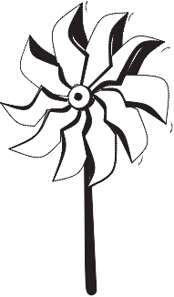MAKING

**Attachment J**

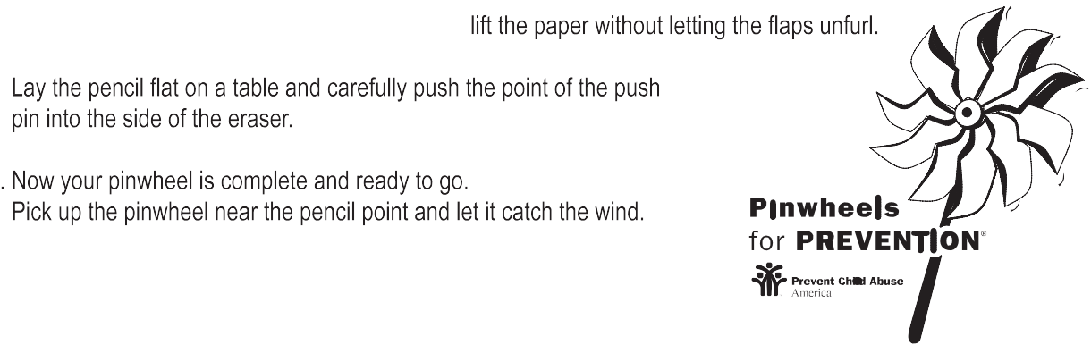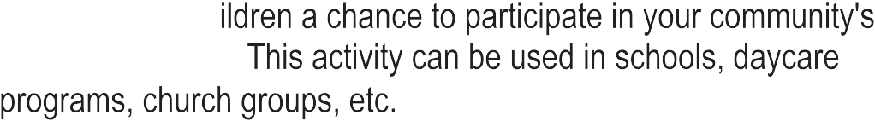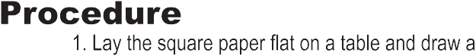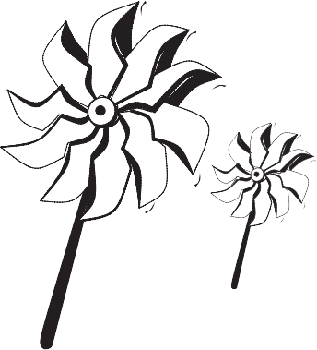

YOUR OWN PINWHEEL

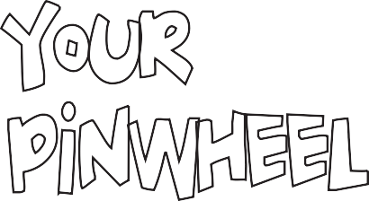

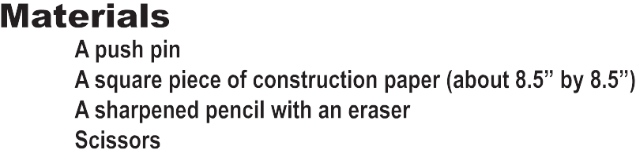

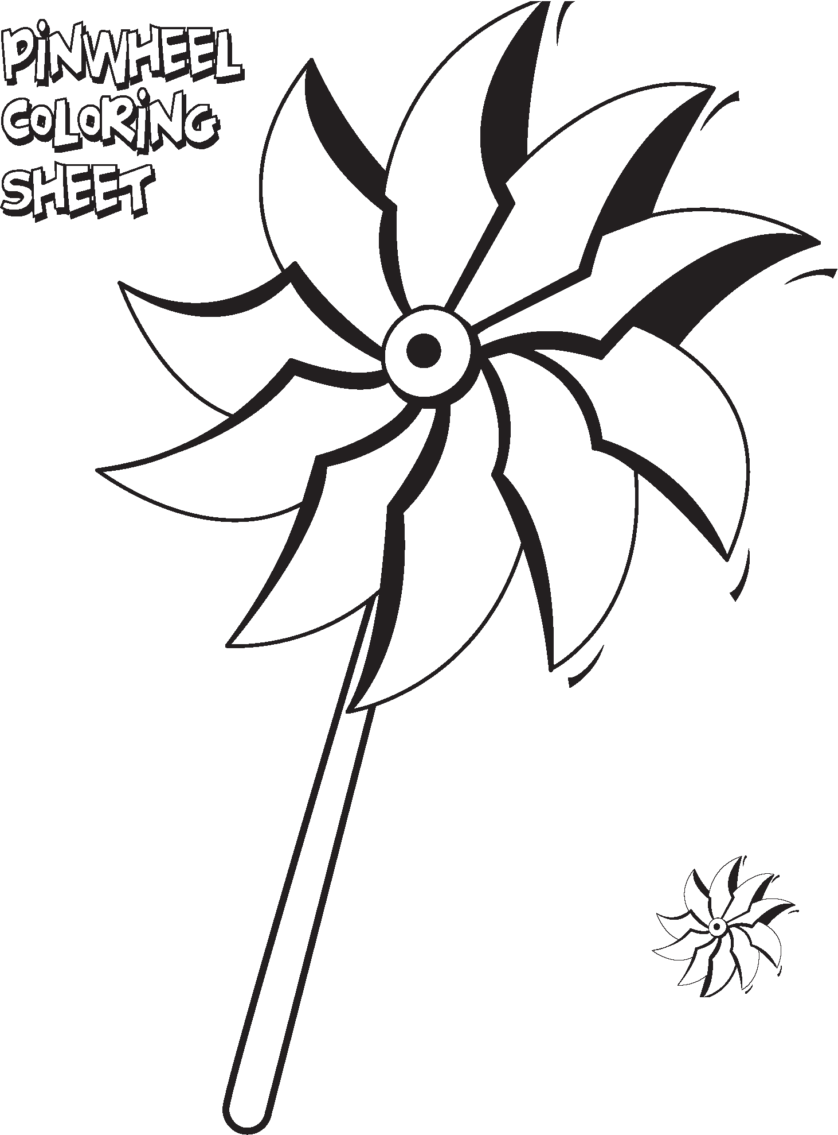

Macintosh HD:Users:Missouri KidsFirst:Desktop:Missouri 2:PCA Logo_MO_2C.eps

Prevent Child Abuse Missouri 2016 Pinwheels for Prevention Campaign

Missouri KidsFirst would like your involvement to be as easy as possible. The following proposals describe how your organization or business can help make an impact on the healthy growth and development of Missouri’s children:

1. Sponsorship:

In celebration of Child Abuse Prevention Month, sponsor a pinwheel(s) displayed in the Missouri KidsFirst “Pinwheel Garden” at the Missouri State Capitol on April 14, 2016. Sponsorships are

$20.00 for each pinwheel.

1. Individual Pinwheel(s):

Sell pinwheels to customers for $1.00 each.

1. Community Pinwheel Garden:

Create a “Pinwheel Garden” in your community. A minimum of one hundred pinwheels must be purchased, offered at a discounted price of $0.80 per pinwheel.

1. Missouri KidsFirst Pinwheel T-Shirts:

Wear your support of child abuse prevention with a Missouri KidsFirst t-shirt. Visit our website to place an order or submit the order form provided in this toolkit.

1. Signature Pinwheel Jewelry:

Missouri KidsFirst has a beautiful collection of rodium plated Tiffany-style pinwheel jewelry available for purchase. Visit our website to place an order.

### Pinwheels for Prevention™ 2016 Order Form

Billing/Shipping Information

Name: Address: City:

State:

Zip:

Phone:

Email:

|  |  |  |  |
| --- | --- | --- | --- |
| Pinwheel Order Pack | Quantity of Pinwheels | Price per Pinwheel | Total |
| A. Sponsorship (Online Ordering Available) |  | $20.00 |  |
| B. Individual Pinwheel(s) (Online Ordering Available) |  | $1.00 |  |
| C. Community Pinwheel Garden (100 minimum) |  | $0.80 |  |
| **Total** | | | $ |
| D. Point of Purchase Donations - Please contact Missouri KidsFirst if interested | | | |

###### Shipping and handling will be billed separately based on actual cost of postage.

*You will not be billed if you pick up your order of pinwheels at our office.*

Payment Method (Make checks payable to *Missouri KidsFirst.*) Check VISA MasterCard DiscoverCard

Card Number: Security No: Amt Authorized: Exp. Date: Name on Card: Signature: Card Holder’s Address:

Send form to:

Missouri KidsFirst 520 Dix Road, Suite C

**Jefferson City, MO 65109 or Fax to: 573-632-4601**

Missouri KidsFirst Pinwheel T-Shirts For SALE

***$5.00 Pinwheels T-Shirts***

**Missouri KidsFirst will no longer be selling Pinwheels for Prevention T-Shirts. Our 2013 and 2014 T-shirt are $5.00!**

**“Anyone who does anything to help a child in his life is a hero to me.” - Fred Rogers**

**Front of T-Shirt**

**Back of T-Shirt**

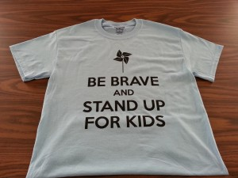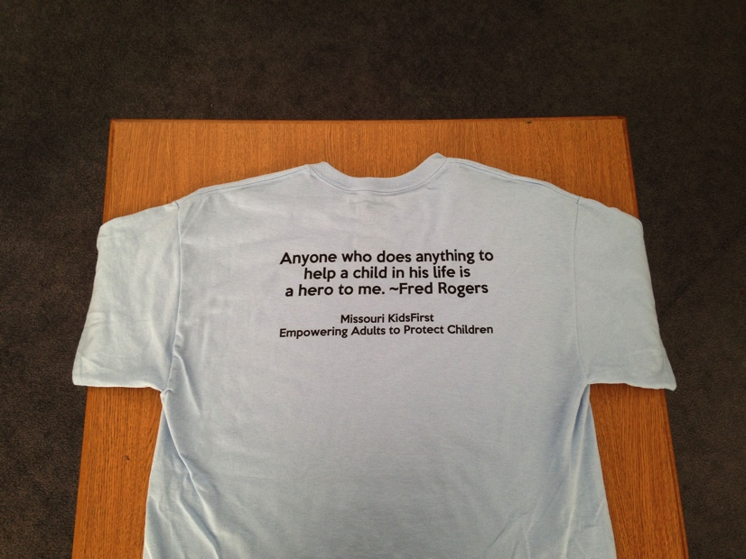

Celebrate the joy that children bring to our lives and wear your support of child abuse prevention with the purchase of our pinwheel t-shirt. The pinwheel t-shirt is light blue with black lettering.

Purchase a t-shirt for yourself, order as a group for your organization or business.

To place an order, visit [**www.missourikidsfirst.org**](http://www.missourikidsfirst.org/)

Sizes available: Small, Medium, Large, XLarge $5.00.

### Messaging for your Pinwheel Activities

Prevent Child Abuse America developed core messages to drive the Pinwheels for Prevention Campaign. It is built on the idea that child development is key to community and economic development:

1. **Child abuse prevention is the most critical issue we can address for long-term prosperity:**
   * Research demonstrates that toxic stress from abuse and neglect impedes healthy brain development, which has an effect on child development, which in turn effects long-term community and economic development.
   * Effective child development efforts lay a strong foundation for a child’s growth and success, and help reduce the long-term costs to society.
   * It’s simple: If we neglect to put safety, healthy growth and development of our children at the top of our priority list, we jeopardize their future and our future.
2. A call to action:
   * At election time, candidates say children are a priority. This is the time to demonstrate it. Write your congressperson, governor, senator, and state representative and talk to them about prevention.
   * Learn more about how we prevent child abuse and neglect, and start conversations with your family, friends and neighbors.
   * Promote the health and well being of every child in your community.
   * Organize your neighbors to ensure prevention services are available for the families in your community.
   * Participate in and/or volunteer your time and skills to youth-serving organizations.
   * Support family or friends who are under stress.
   * Financially support organizations that prevent, address and/or treat child abuse and neglect.

For further information about messaging, access the FrameWorks Institute’s “Talking Child Abuse and Neglect Prevention” toolkit at: <http://www.preventchildabuse.org/index.php>

Pinwheels Messaging

Market research suggests that people associate pinwheels with children and childlike notions. The idea is to rally people around the idea of ensuring our nation’s children are raised in healthy, stable and nurturing environments. We want our communities to see the pinwheel as a symbol for child abuse and neglect prevention, particularly through healthy child development and community sup- port.

1. Equate pinwheels with the number of children served by your organization and encourage other organizations to participate and do the same. For example, if your organization served 550 children in 2015, plant 550 pinwheels in April for Child Abuse Prevention Month.
2. Make a statement about your organization’s support of the campaign, and/or healthy child development and/or child abuse prevention somewhere within your pinwheel garden, or prevention events/ activities.
3. Avoid equating the pinwheel with deaths from reported or confirmed cases of child abuse. The Pinwheels for Prevention Campaign does not want to reinforce negative images that can be counter- productive to the symbol’s image of hope, health and happiness.

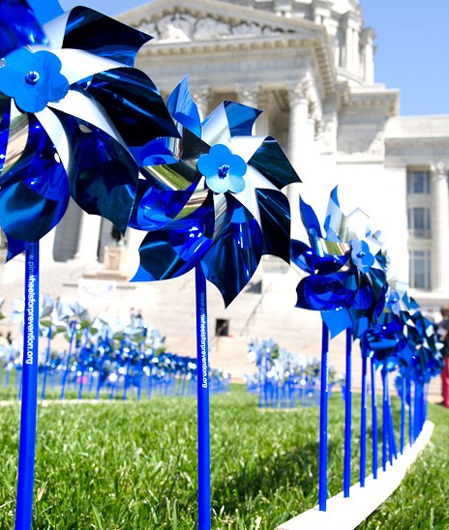

Macintosh HD:Users:Missouri KidsFirst:Downloads:Missouri (2) 2:PfP Logo_MO_2C.eps

##### For more information or assistance, contact:

**Missouri KidsFirst**

**520 Dix Road, Suite C**

**Jefferson City, MO 65109 (O) 573-632-4600**

**(F) 573-632-4601**

[**cherisse@missourikidsfirst.org**](mailto:cherisse@missourikidsfirst.org)[**www.missourikidsfirst.org**](http://www.missourikidsfirst.org/)